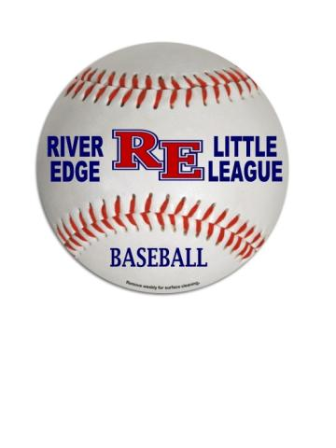
2020 RELL Manager Checklist:
☐ Key for Equipment Box
☐ Key for Memorial bathrooms
☐ Medical Release Form for each player
☐ Copy of Accident Report Form
☐ Equipment bag
☐ Baseballs
☐ Rating Sheet for each player (AA-Major)
2020 RELL Manager Gameday Checklist:
☐ limit of 4 coaches in dugout per game for Major & Minor League, the extra coaches can be in the bullpen or take a game off.
☐ No coaches outside of dugout, which means nobody behind backstop or in the opening
☐ Safety Inspection before games
☐ Trash Inspection after games (Dugout & Stands)
☐ Equipment Inspections throughout the season, if any equipment damaged contact Equipment Manager for replacement/repair.
☐ Submit Scores
☐ Rating Sheet for each player (AA-Major)

Other Important Info:
- Accident Repot Protocol can be found on RELL website
- First Aid – When supplies (i.e. icepacks) are used please contact RELL so bucket can be replenished
- After practice, please rake the field
- Please communicate with your team beyond what is done automatically through the Dick’s website
- Below is the list of division commissioners:
Division | Commissioner
K
A
AA
Minors
Majors

- Any questions/concerns do not hesitate to contact a board member or email riveredgelittleleague@gmail.com

RELL End of Year Equipment Return Checklist:

☐ Key for Equipment Box
☐ Key for Memorial bathrooms
☐ Equipment bag (All Equipment cleaned and wiped)
Catcher Mask
Catcher Shin Guards
Catcher Chest Protector
Catcher Glove
Pitch Count Clicker
☐ Rating Sheet for each player (AA-Major) completed prior to summer selections

